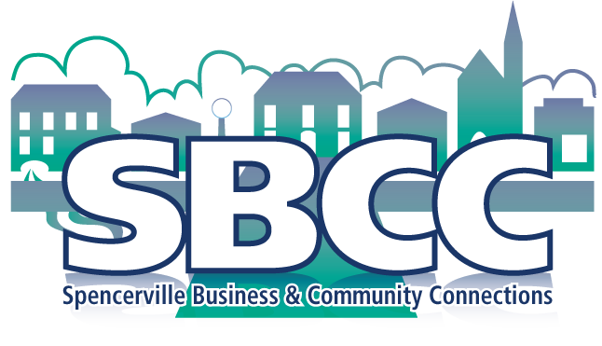

Spencerville Business and Community Connections
Annual General Meeting Agenda
Thursday, March 21, 7-9pm
Spencerville Legion

- 7:00 Meet and Greet
- 7:30 Welcome and introductions: Mary Moore presiding.
- Agenda and additions to agenda; approval of agenda
- Review and approval of minutes from our last AGM, March 27, 2018
- President’s Report
- Treasurer’s report
- Membership report for 2018
- Nominations and election of SBCC Executive:
Please forward nominations ahead of meeting to Mary Moore mary.moore@cedarlanestudio.net
- Executive positions open: President, Vice President, Treasurer, Secretary, Membership and Social Media Chairs
- Motion to approve slate of officers
- New business
- Other SBCC Goals: Mary Moore – Art in the Park, Family Picnic Day, Historic Play
- Municipal grant
- Announcements/coming events
- Next meeting: Tuesday, April 23, 2018 8:00 am at the Legion
- Casual discussion – perhaps under the heading “What would you like to see happening in your community?"
- Membership signups before and after the meeting

