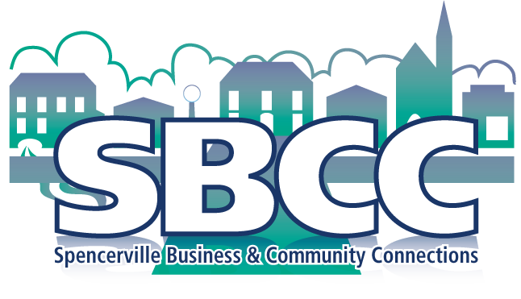
SPENCERVILLE BUSINESS AND COMMUNITY CONNECTIONS
http://www.spencerville-sbccc.ca
Minutes SBCC March 21, 2019, Spencerville Legion_ANNUAL GENERAL MEETING
Present: Kathy Cleary, Bruce Harding, Annalee Ladouceur, Mary Moore, Cornelis Rutte , Sheldon Gill, Myra McFarlane, Connor Cleary, Carol Jones – Packwood, Mark Packood, Sue Turner, Brian Purcell, Alison Purcell. Nick Ketchum, Tom Lillico, Roshan Aubin, Tim Aubin, D. Finnie, Gina Vacchio, Brian Moore, Stephenie Summers, Sheila Dubyk and Helen Piper. Apologies to anyone who was not included!
Opening: President Mary Moore welcomed us all and noted that there were several people present who took time to find out about SBCC first hand.
She thanked Gina Vacchio from Little Sisterz Restaurant for providing refreshments.
Agenda for this meeting was presented and moved by Mary seconded by Annalee and confirmed as presented.
Review and approval of 2018 AGM minutes as written was moved by Roshan, seconded by Annalee and confirmed
President's Report: Mary outlined her three main objectives all in an effort to bring Spencerville businesses to a wider audience.
- To communicate with each other. We have a web site: http://www.spencerville-sbcc.ca, a facebook page and a mail chimp account. We continue to promote joining our email list (member or non-member welcome) so anyone interested can find out our latest events. The sign-up form is linked on the home page and only takes seconds to enlist.
- To encourage partnerships with various members or businesses if an event or project warrants it.
- Membership in this organization will only help everyone to enjoy everything our community has to offer. Membership will create a body of volunteers for community activities, and reach out to young families to enjoy, inform and include them in various local events.
Treasurer's Report: Roshan reported that to December 31, 2018 we had total revenues of 2096.82, and total expenditures of 917.61 for a remaining balance of 1179.21 Roshan moved and Carol seconded that this report be accepted as presented – confirmed.
Membership Report: Annalee reported in 2018 SBCC had 32 members – and we hope to keep those numbers up! SBCC is encouraging Associate Members – those who will join as an individual and do not necessarily have a business. These people will be aware of various projects and able to assist by volunteering their time at various activities. Associate membership is $25.00. Event and activity ideas are welcome from all!
Business Membership is $50.00. Business members may advertise on the sign board at the T junction just before Spencerville. Kathy Cleary curates the sign board, and will make signs if needed – details on our web site , or contact her at clearykw@outlook.com.
Nomination and election of SBCC executive: Several people have agreed to serve another term – President: Mary Moore; Treasurer Roshan Aubin; Secretary Helen Piper; Membership Annalee Ladouceur
We are looking for a Vice President and a Social Media Officer who will post on Facebook PLEASE have ideas for these positions by next meeting! Approval for the existing slate of officers was moved by Carol and seconded by Gina, confirmed. Mary Moore will post these results on the Facebook page.
Discussion:
The meeting was followed by a casual discussion exploring ideas of what those present might like to see in future
Explore activites with nearby communities..perhaps Cardinal or South Mountain possiblya community party held one week at one venue...one week another
As there are so many local Artisans.. have Art in the Park expand a little to include local artists display from their homes. Could be called an ART CRAWL in Spencerville. Proposed by Casey Rutte of Art & Mart/Cassandra Steam Punk
New Business:
Municipal Grant was applied for by Sheila Fawcett. In kind services will mainly be used this year to cover the Progressive Play and Dinner
Art in the Park..Looking for a one day Art show of local people in out Park near the Mill. It is hoped that Doug Hall's Garden and an Art Station for kids will be part of this..as well a food and fun.
Thought was given to a Family Picnic Day at the same venue
Historical Play..Coming this Fall October 19 and 20 this will be a three stage play and food event staged at some of our most Historic sites..it will begin at the Mill, proceed to the Presbyterian Church and end up at the Spencer City Bar and Grill. There will be three short plays and food at each venue..As we can accomodate only 60 people per show..we will have 2 performances. A 2 1\2 hour experience.
Announcements:
Little Sisterz Wine Cocktails and Hors d’ouevres Pairings: April 11. Contact Little Sisterz to reserve - (613) 648-8888
Ladies night at the Drummond Building April 13th Limited tickets still available 613.658 3333 to order
Sue Turner's Spring Yoga at the Twp Hall starts April 17th for 10 weeks. Wednesday 10 -11.30
Optimist's Club Spaghetti Dinner coming soon – we’ll keep you posted!
Fire Department Barrel Races at the Mill: Tickets available from firefighters on the day or at the firehall beforehand. Date around Easter when water is right height.
Meet your Council at Council Chambers April 29th at 5.30pm a chance to meet the new council members.
NEXT MEETING Tuesday April 23, 2019 Spencerville Legion 8 am. Come as member or Guest

